Subscriber Client User Guide

Table of Contents

**ABOUT THIS GUIDE** **1**

**INTRODUCTION** **2**

**1 GETTING STARTED** **3**

1.1 User Login 3

1.2 Change Password 3

1.3 Reset Password 4

**2 HOME PAGE 5**

2.1 Navigation Panel 5

2.2 Sidebar 6

**3 DASHBOARD PAGE 7**

3.1 Dashboard 7

**4 LICENCE DETAILS PAGE 8**

4.1 Subscriptions 8

**5 ORDER HISTORY PAGE 9**

5.1 Order History 9

**ABOUT THIS GUIDE**

This guide has been developed to guide you through the SubscriptionApp features with concise and step-by-step method of instructions. This guide is intended to use by clients.

**INTRODUCTION**

Subscription Client Web App is an application which provides a way for the IT administrators(Clients) to view the record of all licenses been procured. This application enables users to know licence details which includes the information of the licence start Date, expire Date for the respective applications and servers(Machine). Report on the detail of the orders made and allows to download them spreadsheet.

**1** **GETTING STARTED**

**1.1 User Login**

To login, browse to the Subscription interface at:

[http://<local IP address / host name>](http://servername)

Next, enter the **username/email id & password** and click on login button.

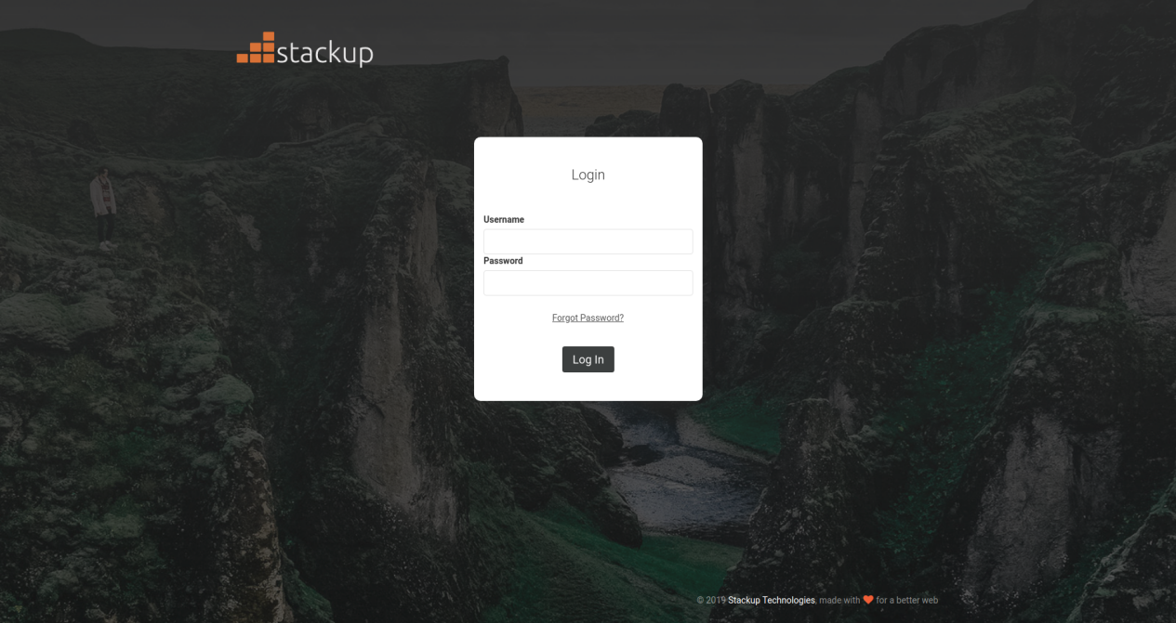

**1.2 Change Password**

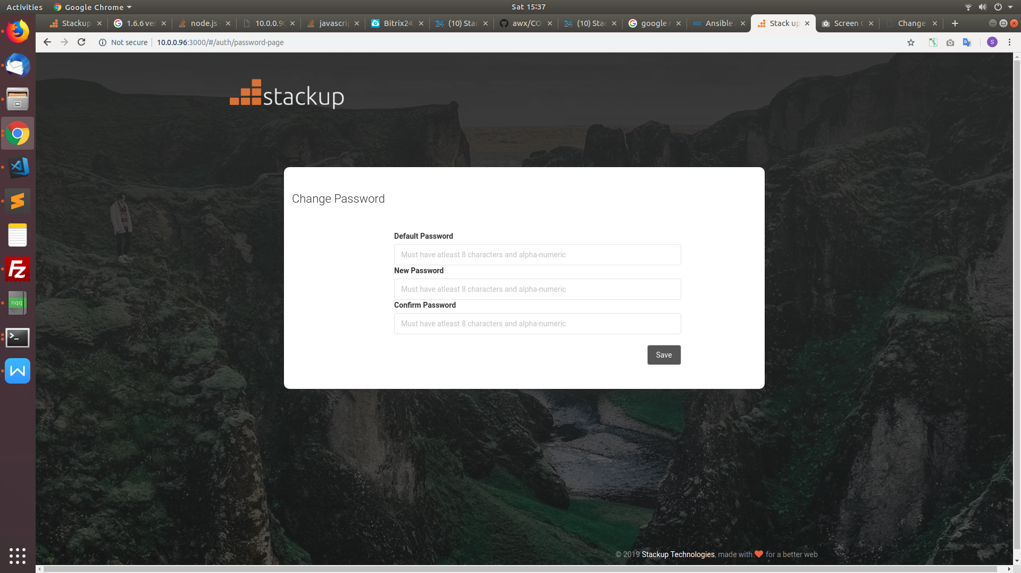

To change the password, do the following:

* Enter the old password in the **Old Password** Field.
* Enter a new password in the **New Password** and **Confirm Password** fields. The password is case sensitive and must match in both fields.
* Click **Save** to complete the process.

**1.3 Reset Password**

If user forgets the password, do the following:

* Navigate to the Stackup login screen.
* Click **Forgot Password?**
* Enter the username, and click **Submit**.

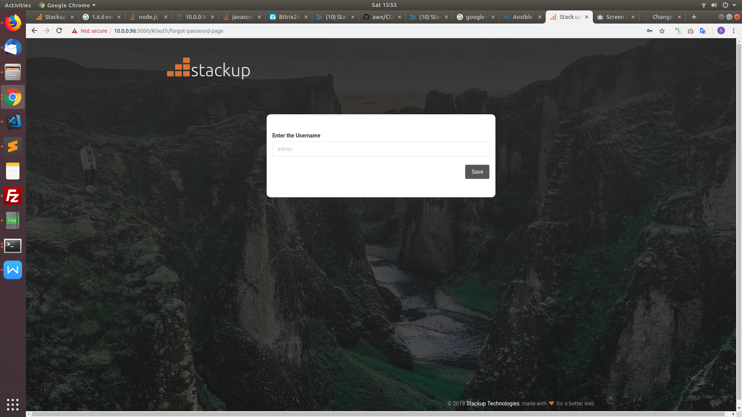

* You will be receiving a mail regarding reset password, click on the link provided and you will be redirected to the reset password screen.
* Now Reset the password

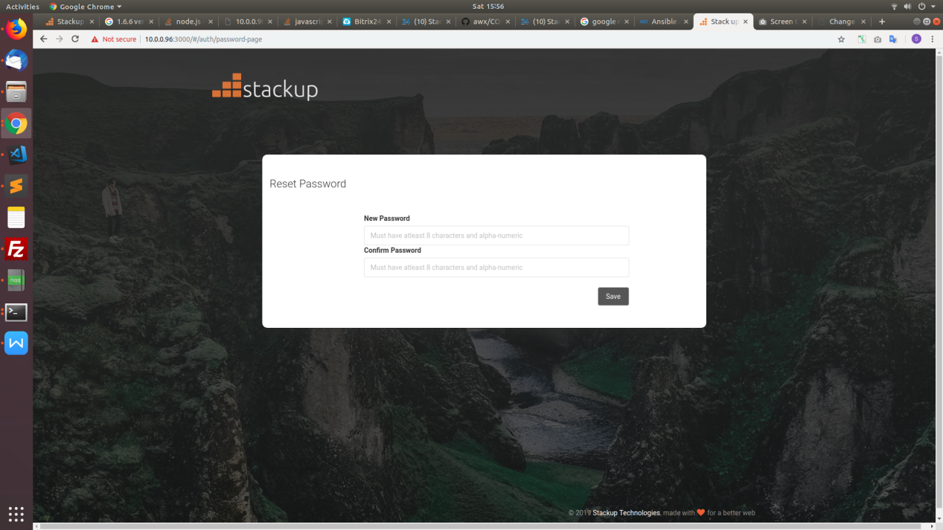

* Click save. It redirects to login screen

**2** **HOME PAGE**

The home screen by default contains two portions: the navigation panel and the sidebar.

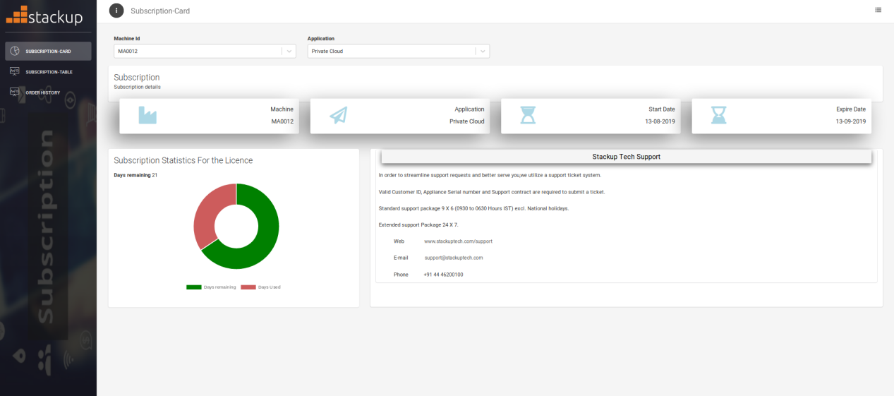

**2.1 Navigation Panel**

On the top of the navigation panel menu icon contains two options in the form of drop down which includes change password and logout

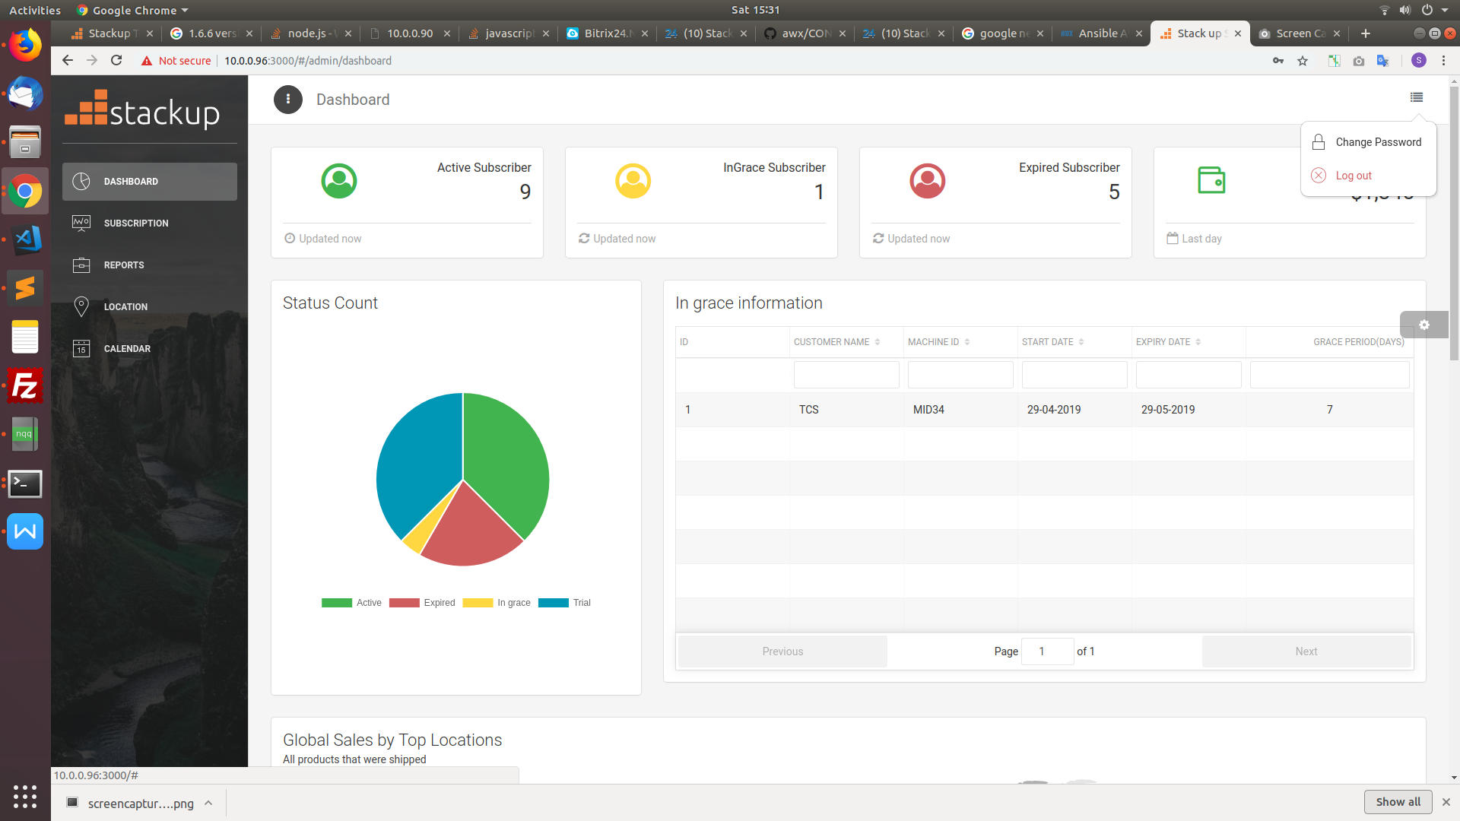

* Change Password

On Click of Change Password icon redirects user to Change password page.

* To logout,

On click the **Logout** icon the user gets logged out.

**2.2 Side Bar**

On the left side of the UI is the side bar. It allows the user to view the content and activities in a streamlined way

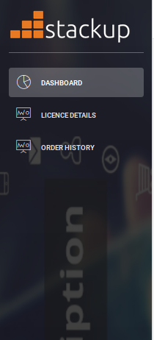

**3 DASHBOARD PAGE**

**3.1 Dashboard**

The dashboard gives over view on a particular licence in a pictorial representation.

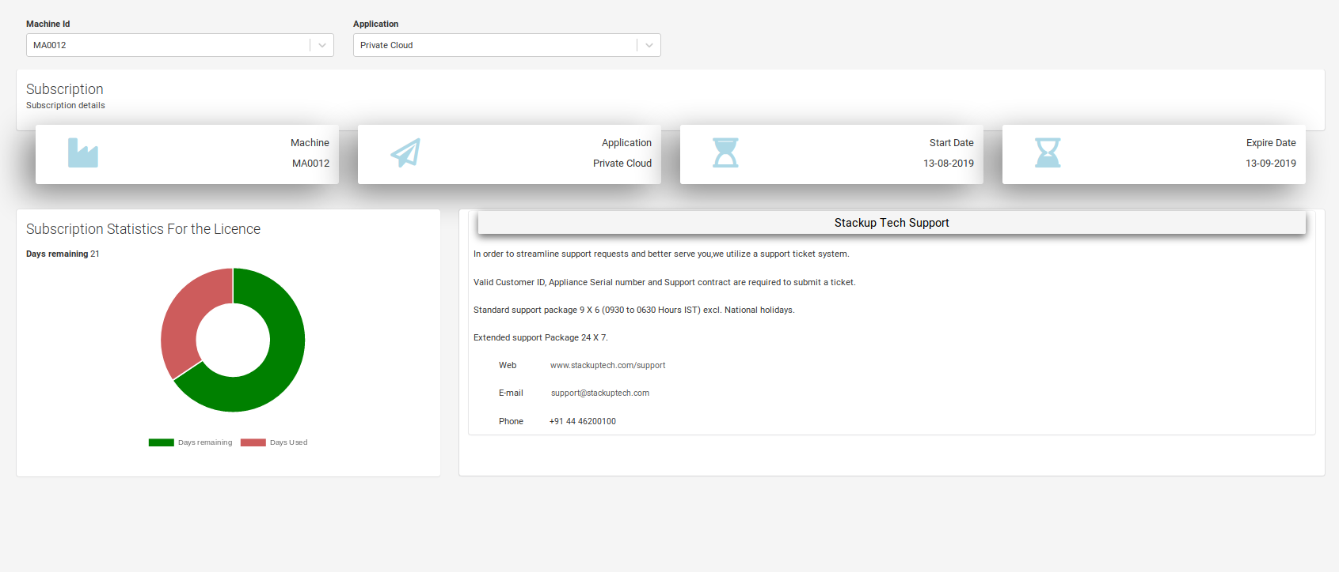

It allows to select the server/machine id and the application from the drop down menu and displays the respective licence information below with the licence commencing and expiry date details and provides the usage statistics in the Doughnut chart below.

**4** **LICENCE DETAILS PAGE**

**4.1 Subscriptions**

This page displays the list of licence procured in the tabular format including the information of Machine ID, the Application Name, Licence start date, expiry date, the current status of the licence.

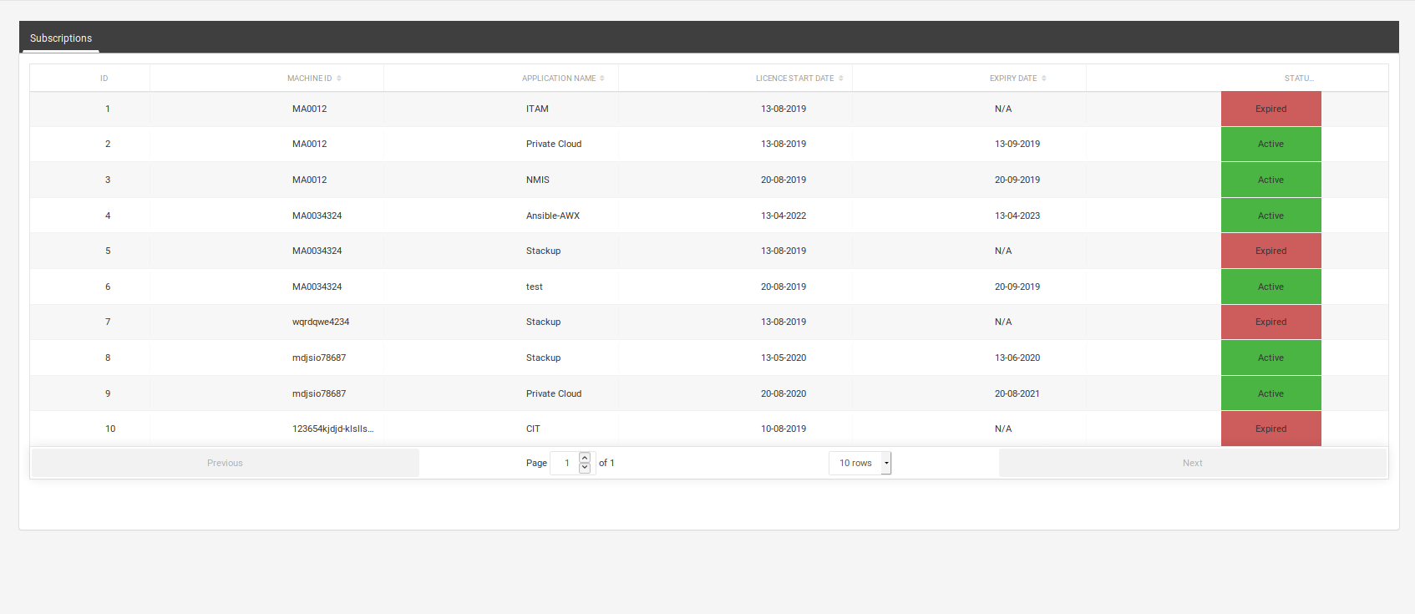

**5** **ORDER HISTORY PAGE**

**5.1 Order History**

This page displays the Order History of the various licence procured in the tabular format including the information of Machine ID, the Application Name, the licence type, Order issue date, Licence start date, expiry date, the count of grace period provided for the particular licence.

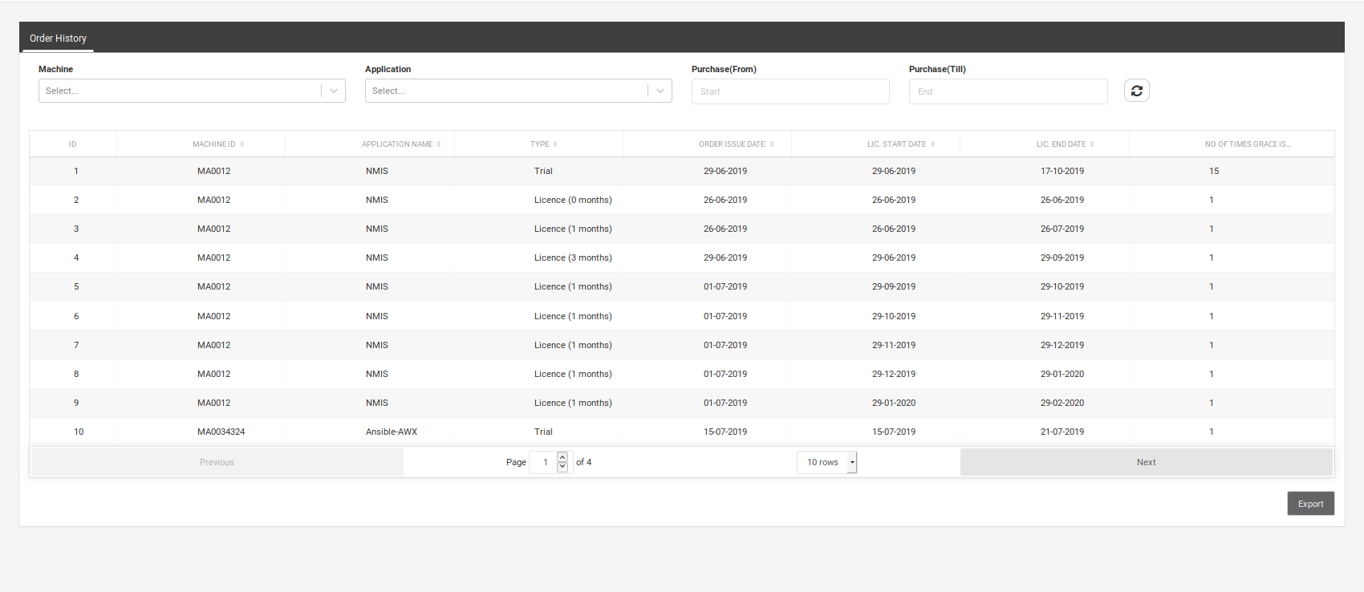

**Downloading Report**

You can download the Report by clicking the **Export** button. The downloaded file will open in a spread sheet.